In the **Code** step in Model Builder, select **Add Projects**.

Model Builder adds both the machine learning model and the projects for training and consuming the model to your solution. In the Solution Explorer, you should see the code files that were generated by Model Builder.

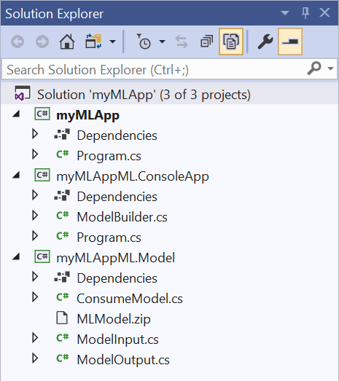

myMLAppML.ConsoleApp is a .NET console app that contains ModelBuilder.cs (used to build/train the model) and Program.cs (used to test run the model).

myMLAppML.Model is a .NET Standard class library that contains ModelInput.cs and ModelOutput.cs (input/output classes for model training and consumption), ConsumeModel.cs (class that contains method for model consumption), and MLModel.zip (trained serialized ML model).

**ML.NET Concepts for each Tutorial(in-depth compared to commenting used)**

1. **Sentiment Analysis**
2. **Categorize Support Issues**